Assignment 9
9.1 A coffee manufacture is interested in whether the mean daily consumption of regular coffee drinker is less than that of decaffeinated-coffee drinkers. A random sample of 50 regular-coffee drinkers showed a mean of 4.35 cups per day, with a standard deviation of 1.20 cups per day. A sample of 40 decaffeinated-coffee drinkers showed a mean of 5.84 cups per day, with a standard of 1.36 cups per day. Use the 0.01 significance level. Compute the p-value.
9.2 An Ohio university wishes to demonstrate that car ownership is detrimental to academic achievement. A random sample of 100 students who do not own cars had a mean grade point average (GPA) of 2.68, while a random sample of 100 students who own cars had a mean GPA of 2.55.
a. Set up the null and alternative hypotheses that should be used to attempt to justify that the mean GPA for non-car owners is higher than the mean GPA for car owners.
b. Test the hypotheses that you set up in part a with 0.05 level of significance. Again assume that 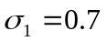 and 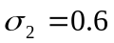. Interpret the results of this test. That is, what do your results say about whether the university can statistically justify that car ownership hurts academic achievement?
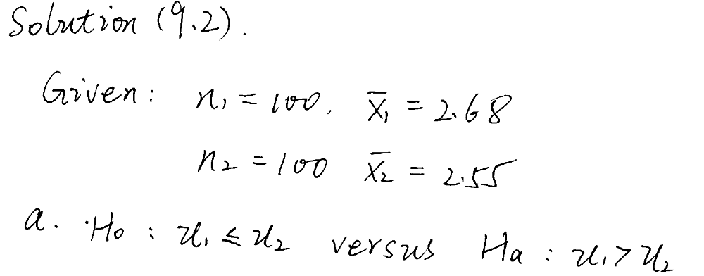
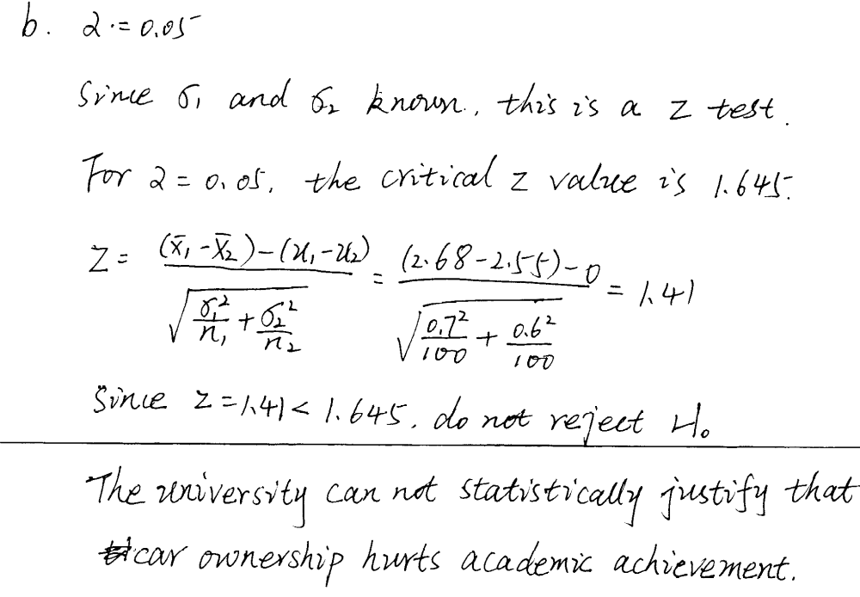

9.3 The Computer Anxiety Rating Scale (CARS) measures an individual’s level of computer anxiety on a scale from 20 (no anxiety) to 100 (highest level of anxiety). Researchers at Miami University administered CARS to 172 business students. One of the objectives of the study was to determine if there is a difference between the level of computer anxiety experienced by female and male business students. We assume that variances of two populations are equal.
 | Males | Females
 | 40.26 | 36.85
s | 13.35 | 9.42
n | 100 | 72
- At the 0.05 level of significance, is there evidence of a difference in the mean computer anxiety experienced by female and male business students?
- Determine the p-value and interpret its meaning.
- What assumptions do you have to make about the two populations in order to justify the use of the t test?
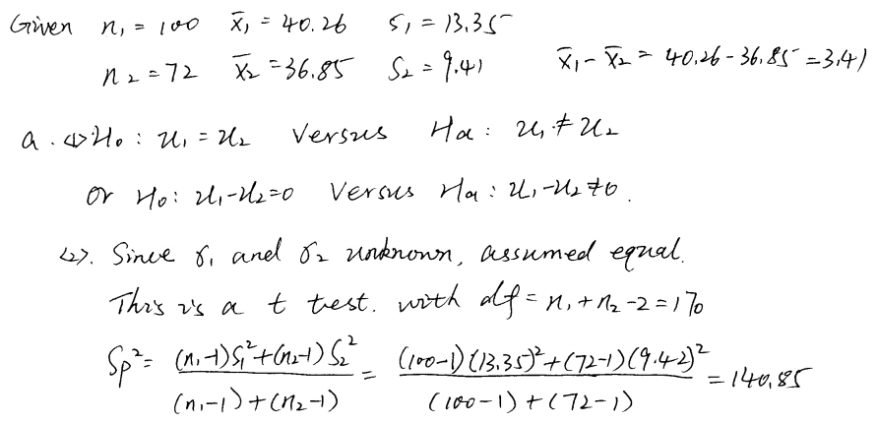
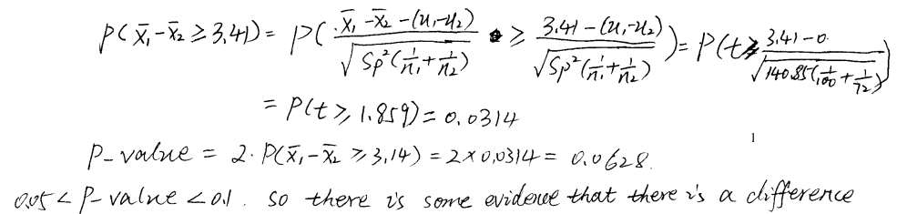

9.4 Multiple myeloma or blood plasma cancer is characterized by increased blood vessel formulation (angiogenesis) in the bone marrow that is a prognostic factor in survival. One treatment approach used for multiple myeloma is stem cell transplantation with the patient’s own stem cells. The following data MYELOMA represent the bone marrow microvessel density for patients who had a complete response to the stem cell transplant as measured by blood and urine tests. The measurements were taken immediately prior to the stem cell transplant and at the time of the complete response.
Patient | Before | After
1 | 158 | 284
2 | 189 | 214
3 | 202 | 101
4 | 353 | 227
5 | 416 | 290
6 | 426 | 176
7 | 441 | 290
- At the 0.05 level of significance, is there evidence that the mean bone marrow microvessel density is higher before the stem cell transplant than after the stem cell transplant?
- Interpret the meaning of the p-value in (a).
- Construct and interpret a 95% confidence interval estimate of the mean difference in bone marrow microvessel density before and after the stem cell transplant.
Solution:
a. 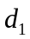=-126, 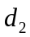=-25, 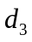=101, 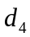=126, 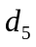=126, 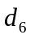=250, 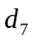=151
: 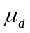0 : >0
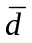=86.14 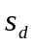=123.7
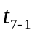=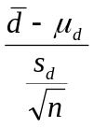=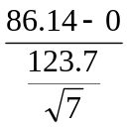=1.842
Critical value: 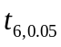=1.943
Since 1.842<1.943, we can’t reject at 0.05 level of significance and there is not enough evidence that the mean bone marrow microvessel density is higher before the stem cell transplant than after that.
b. p-value=p(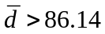)=p(>1.842)>0.05
So we can’t reject at 0.05 significance level and get the same conclusion as in a.
c. 95% confidence interval estimate of the mean difference is
[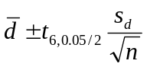]=[86.142.447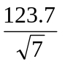]=[-28.27,200.55]
We can be 95% confident that the mean of all possible difference in bone marrow mocrovessel density before and after the transplant is between -28.27 and 200.55.

  - A number of minor automobile accidents occur at various high-risk intersections in Teton County despite traffic lights. The Traffic Department claims that a modification in the type of light will reduce these accidents. The county commissioners have agreed to a proposed experiment. Eight intersections were chosen at random, and the lights at those intersections were modified. The numbers of minor accidents during a six-month period before and after the modifications were:
 | Number of Accidents
 | A | B | C | D | E | F | G | H
Before | 5 | 7 | 6 | 4 | 8 | 9 | 8 | 10
After | 3 | 7 | 7 | 0 | 4 | 6 | 8 | 2
At the 0.05 level of significance, is there evidence that the modification in the type of light will reduce the accidents?
